GIT CREDENTIAL ISSUE:

GENERATE TOKEN

By giving all permission

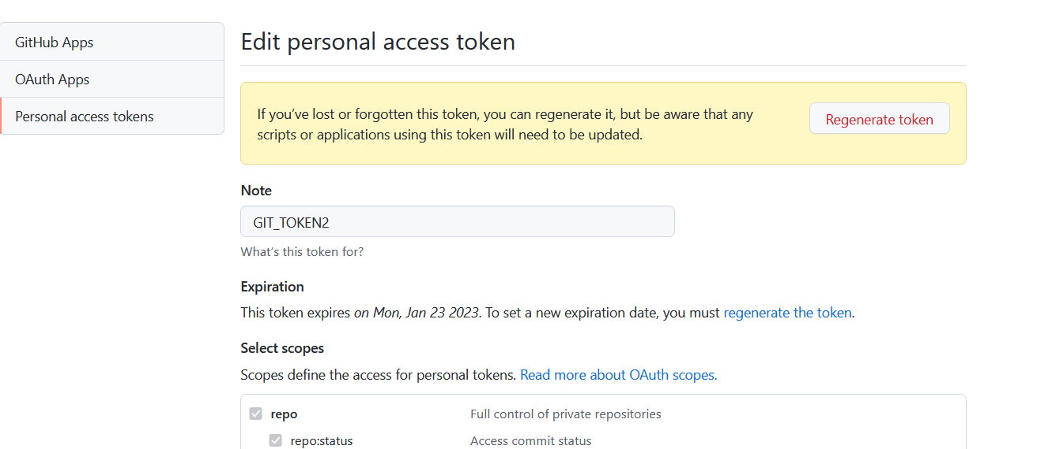

GO TO WINDOWS CREDENTIAL and add username and token

